**Figure S1. Manhattan plots**

1. Genome wide association study summary statistics

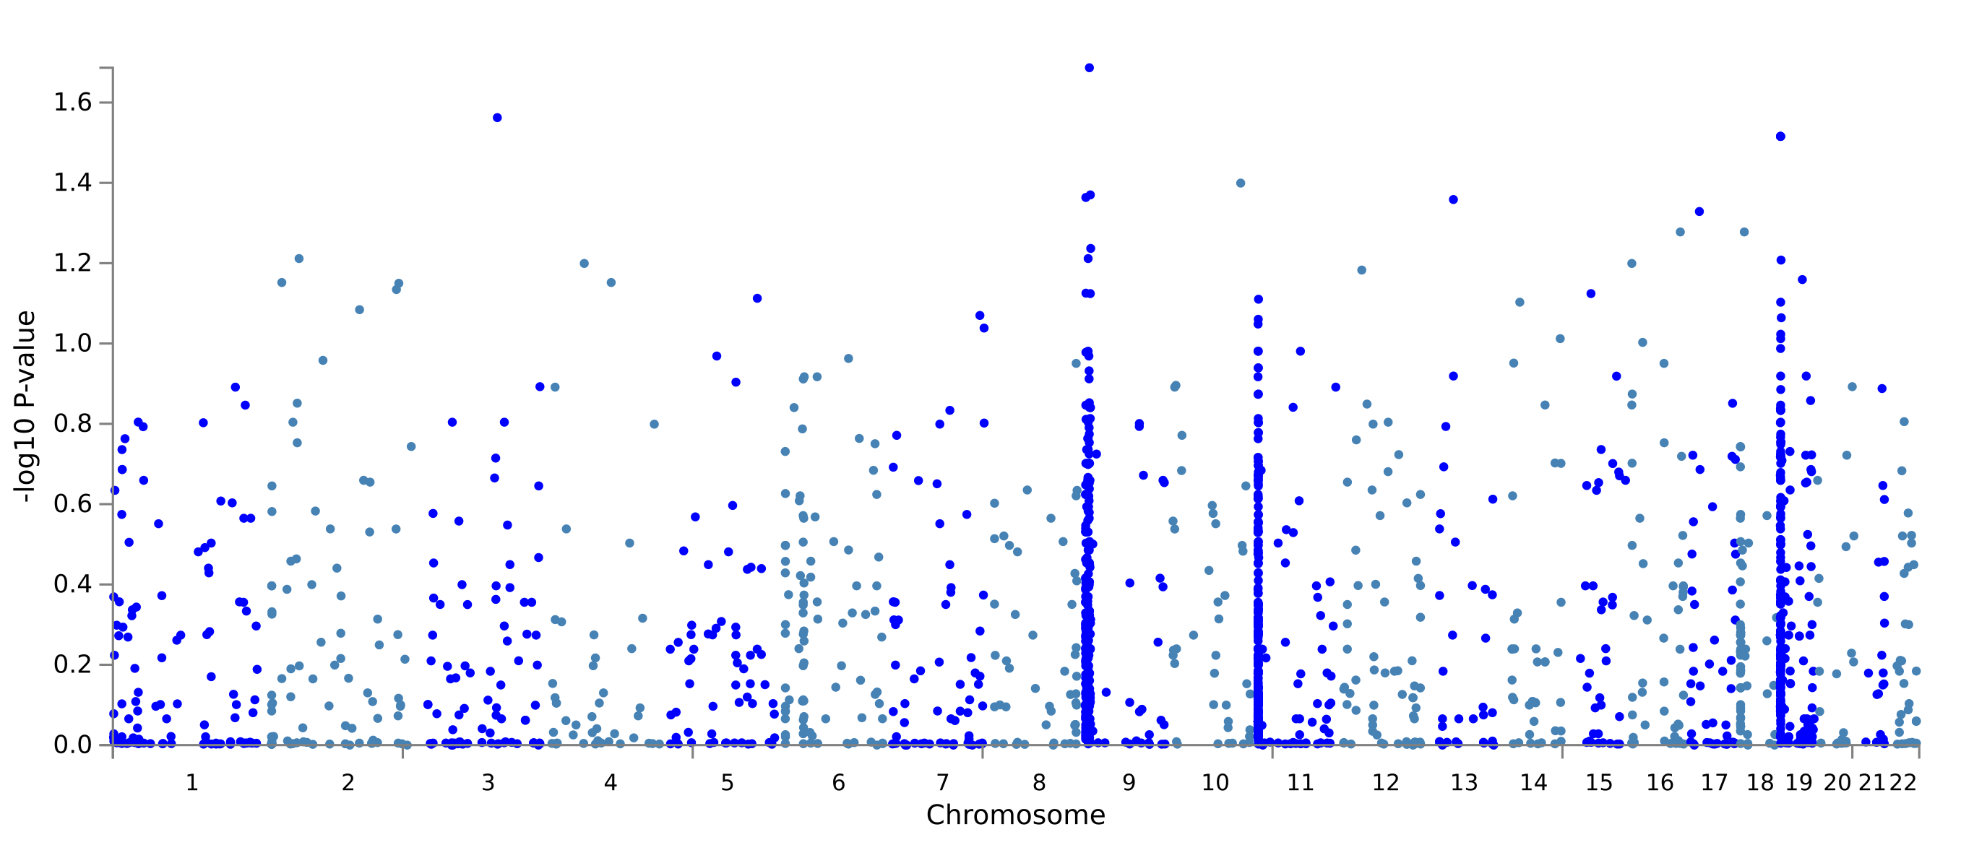

1. Gene-based test

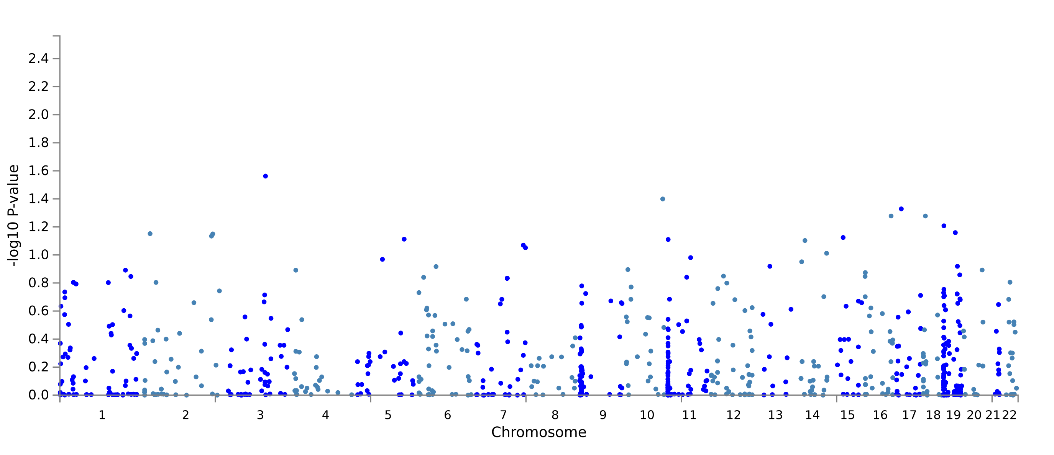

**Legend.**

Manhattan plots for (**a**) genome wide association study (GWAS) summary statistics based on PLINK2v3.7 input of significant mapped candidate single nucleotide polymorphisms (SNPs) (n=909 unique out of 986 total) associated with the chronic graft-versus-host-disease positive (cGVHD+) group and (**b**) gene-based test computed by the Multi-marker Analysis of GenoMic Annotation (MAGMA) tool based on GWAS summary statistics. Input SNPs were mapped to 804 protein coding genes. Filtering was completed only for SNPs with a p-value ≤1x10-5. Genes were determined as significant at a p-value of 6.219x10-5 (0.05/804).